# ***Challenge Name :- Http Object Header***

**Description:-** Decipher the HTTP Object hidden within the depths of the pcap file, revealing its secrets and uncovering its potential vulnerabilities.

**Level:** Easy

**Solution:**

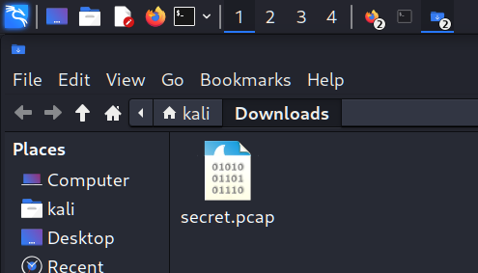

Step 2: Start WireShark and Click to open pcap file in it

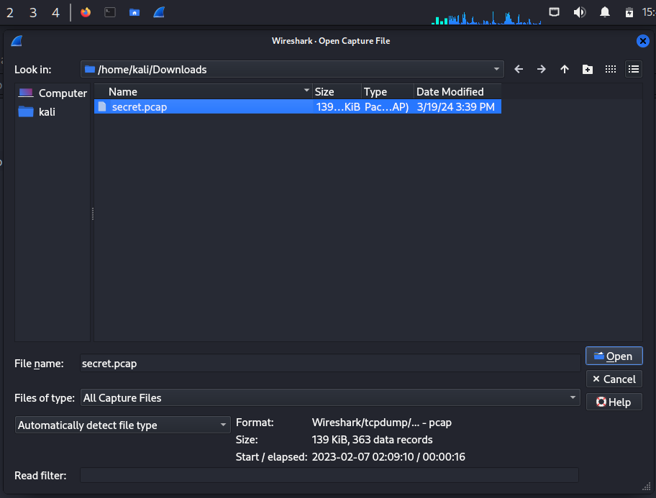

Step 3 : Now analyze captured packets and then search for http object

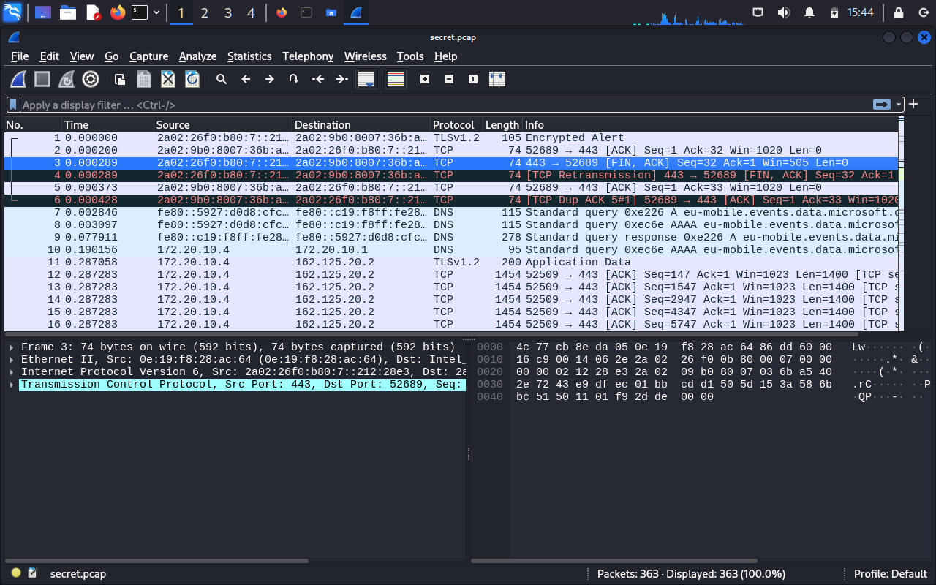

Step 4 : Apply filter http for filtering only http request and response

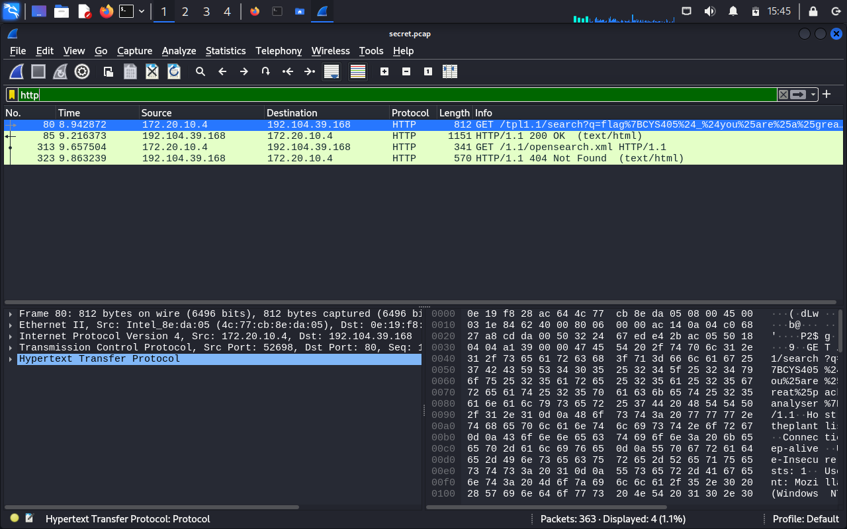

Step 5 : Open each finding to explore flag, and then remove jun character like %7 %24 to get a clear meaningful flag.

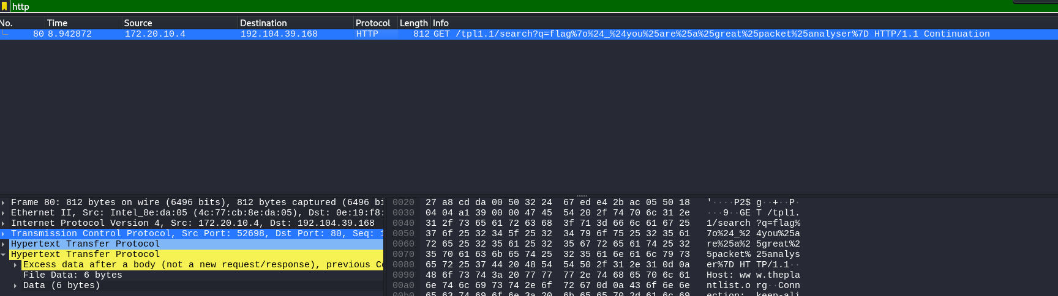

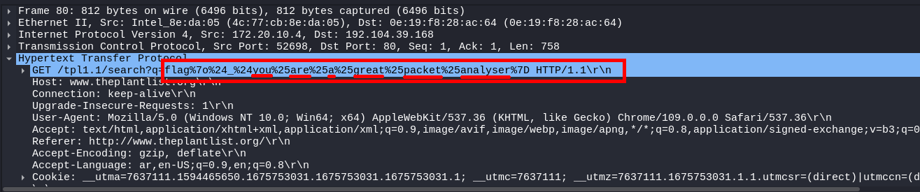

Step 6 : Final flag flag after clearing %7o%24_24you%25are%25a%25great%25packet%25analyser%7D

Hence the flag is:- flag{youareagreatpacketanalyser}

This page is intentionally left blank